Design document

# 

# Table of contents

**Version history** **2**

**Table of contents** **3**

**Introduction** **4**

**Sketches** **5**

**Wireframes / interactive prototype designs** **6**

**Color scheme** **7**

**Use cases** **8**

**Personas** **9**

**Entity Relationship Diagram** **10**

**Logo** **11**

Sketches 11

Sketch 1 11

Sketch 2 12

Sketch 3 12

Sketch 4 13

Sketch 5 (Final logo) 13

Version 1 13

Symbolism 14

Combination 15

Version 2 15

Radar Concept 15

# 

# Introduction

This project is assigned to us for educational purposes by Fontys.

Our client Olha Bondarenko who is working for township Eindhoven asked us to think about how a mobile application could help solve neighbourhood problems.

There is also a second client whose name is Kees van den Broek. Kees van den Broek created a low code platform. Kees asked us to use his technology to create the application.

The project is realised in the following period: 07-05-2020 till 02-07-2020.

# Sketches

# 

# App designs

## Introduction

We used an orange / dark gray color scheme for the buttons and other clickable objects and and Product Sans font for the text and input boxes. We tried to use a lot of material design in our app and sometimes made our own version of it. In the whole design process we have looked how material design handles different situations and designs. We also used some material design icons.

## 

## Colors and fonts

## Pages

### 

### 

### 

### 

### Login page

The first thing we made was the login page. We used the orange input boxes and a login button below it. In between we added a ‘forgot your password’ button. On the bottom we added a ‘sign up’ button, that leads to the signup page in case you don’t have an account yet.

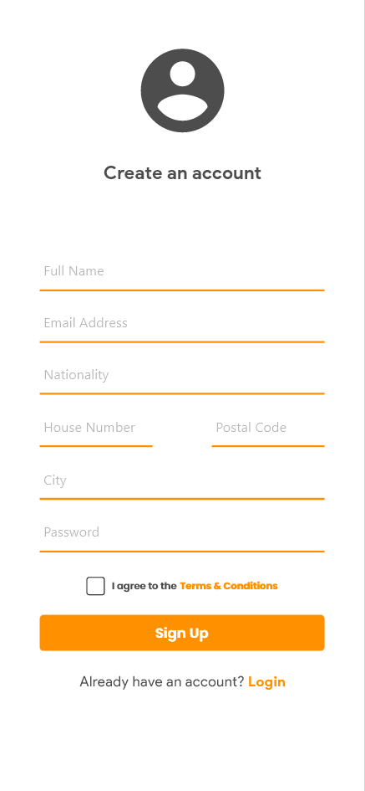

### 

### 

### 

### 

### Signup page

For this page we also used orange input boxes for all the information. Below the form is a ‘terms and conditions’ button that currently doesn’t lead anywhere, but should have a use in the future. Below this is the big orange ‘sign up’ button. In case you didn’t mean to go to this page, you can also go back to the login page by clicking on the button on the bottom of the page.

### 

### 

### 

### 

### 

### Homepage

After signing in, you will be greeted by the homepage. On this page you can see your name and picture on top. Below this is a day-slider, where you can decide for what day you want to see the available events.

The events part of this page consists of a category filter at the top right, and underneath that is the list of currently available events for this day. All the way on the bottom we made a navbar, that you can use to navigate to your account, the create event page and back to the home page.

# 

## 

## 

## Eventpage

After you click on an event on the homescreen, you get redirected to this page. At the top of this page you can see a picture of the activity and the title. Below this is the date and time, and one line later you can see the location. After this part there is a short description of the activity.

At the end of the information form you can see how many different nationalities are going to this activity, and how many people are going in total. At the bottom of the page there is a button to confirm you’re going and a ‘not interested’ button that will redirect you to the homescreen.

## 

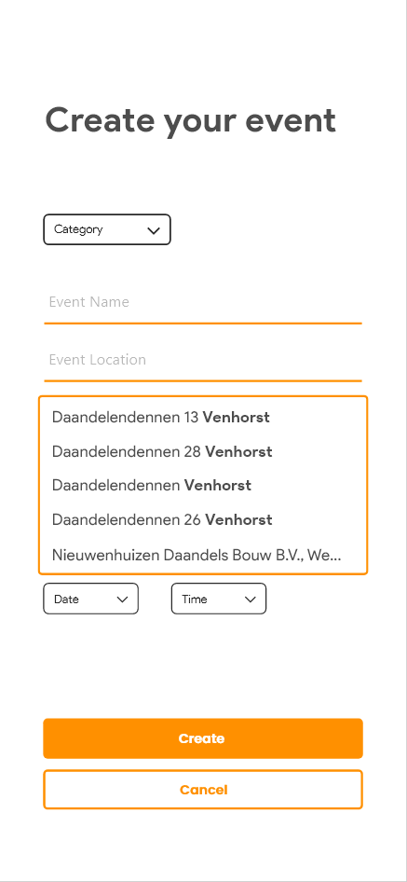

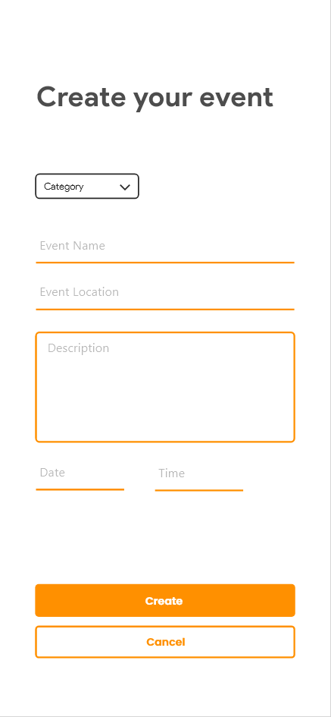

## 

## Event creation page

if you click on the plus button on the homepage you get directed to the event creation page. On this page you can create an event with the the specific information. You need to set the category, event name, location, date and time but the description is optional. Of course you can confirm everything and create the event with the create button.

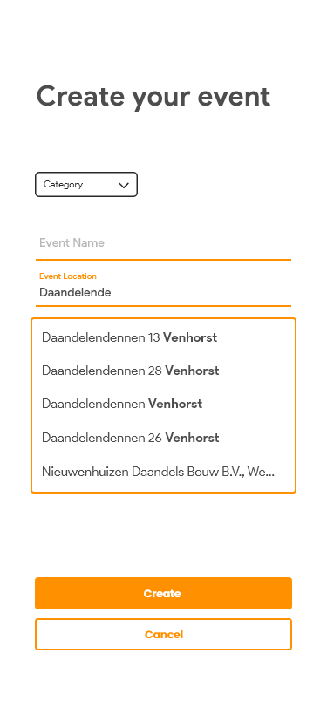



## Location suggestions

Once you type something in the Event location input box the app gives you suggestions of which locations your might mean based 0n what you have already typed in.

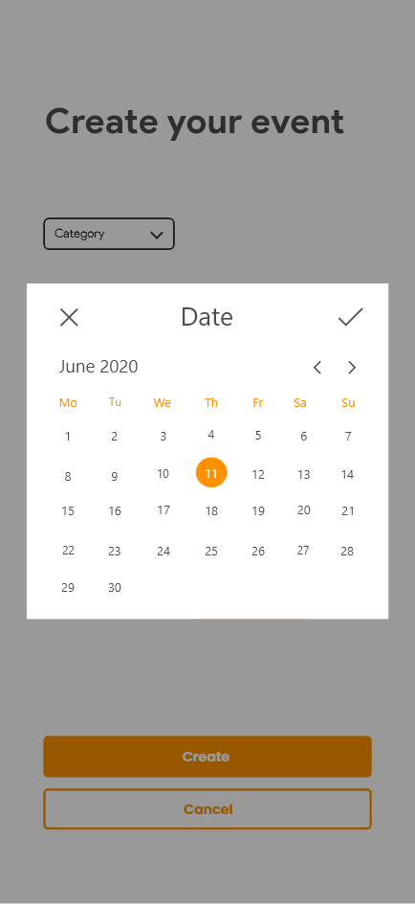

## 

## Event creation - date picker

When you click on the Date input this popup will appear. With this popup you can set the date for the event. You select a date by clicking on a day number. You can slide horizontally to go to the next month. Once you have selected your date you can confirm your date with the check button.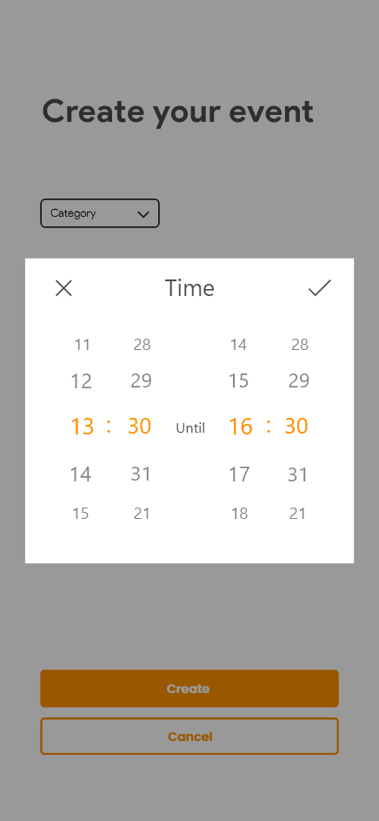

## Event creation - time picker

## The same applies when you click on the Time input. With this popup you can set the time bij scrolling on of the four vertical time sliders. And again you can confirm you choice by clicking the check button.

## 

# 

# 

# Entity Relationship Diagram

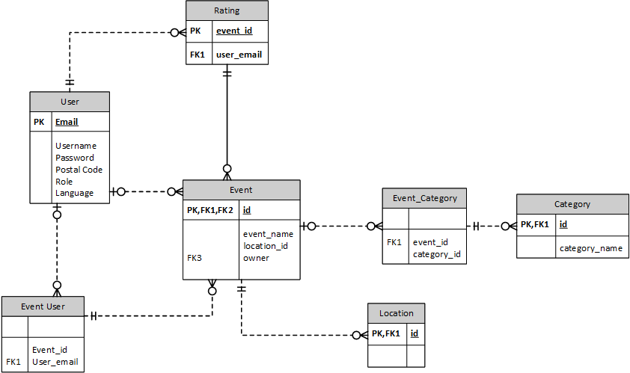

# Logo

## Sketches

We didn’t really know where to start with the logo design, because we didn’t really have a clear plan on what kind of logo we wanted. Therefore, we decided we were gonna make a bunch of very simple but different logos, so we could get some inspiration for an end result.

### Sketch 1

For the first sketch we decided to make a big round circle with an opening to the right, to make it look like a ‘C’. In that gap we placed the letters LY capitalized. We decided to go for a complete monotone color scheme, with dark gray as the only color used.

The circle symbolizes a circle of friends (which is what our app tries to achieve), and the opening to the right symbolizes being open minded to different cultures.

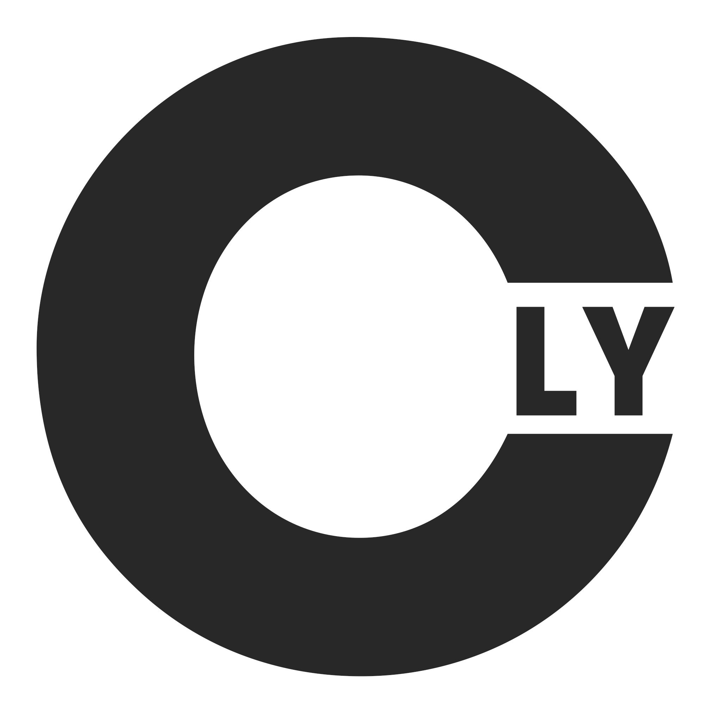

Eventually we decided that this logo was a little bit too boring, so we scraped it and went on to the second sketch.

### Sketch 2

For the second sketch we wanted to incorporate our color scheme for the app a little more. These logos are both relatively simple. For the left one, we just typed the word ‘connectly’ in the ITC Avant Garde font, and colored the ‘l’ and the ‘y’ in our orange color. We also made a shorter version (on the right), but quickly decided to scrap that in favor of the left one.

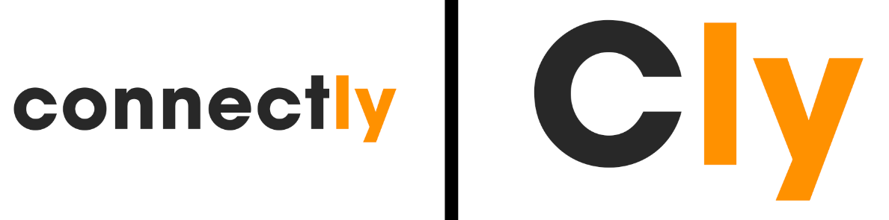

We weren’t going to use just the text on the left as a logo, but it would turn out to be a good subtext for our more compact logo in the end.

### Sketch 3

The third sketch started out as a variation of the previous one. This time however, we seperated the ‘ly’ from the rest of the word, by putting it half below ‘connect’. To give it something extra, we added a line of the same thickness as the rest of the font below the top part.

After this we created a second version, where we colored the lower part of the logo orange, to distinguish it from the upper part. The problem with this version was the fact that the ‘l’ didn’t really look like one anymore, and instead looked like part of the line to the left of it.  
To counter this problem, we made a third version where we separated the line from the ‘ly’, to make sure it doesn’t blend together.

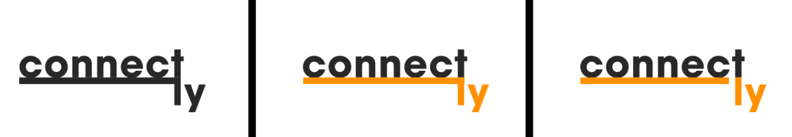

This logo was not very compact however, which is why we decided not to use it as our final result.

### Sketch 4

This sketch started of with the logo that we made for the second sketch. We wanted to add something on to that logo to see how it would look. After a bit of thinking we went with a signal icon above the ‘o’, to symbolize the ‘connect’ part of our name. We made 2 circles around the ‘o’, and removed the lower part of these circles, so that the radar design came together pretty well.

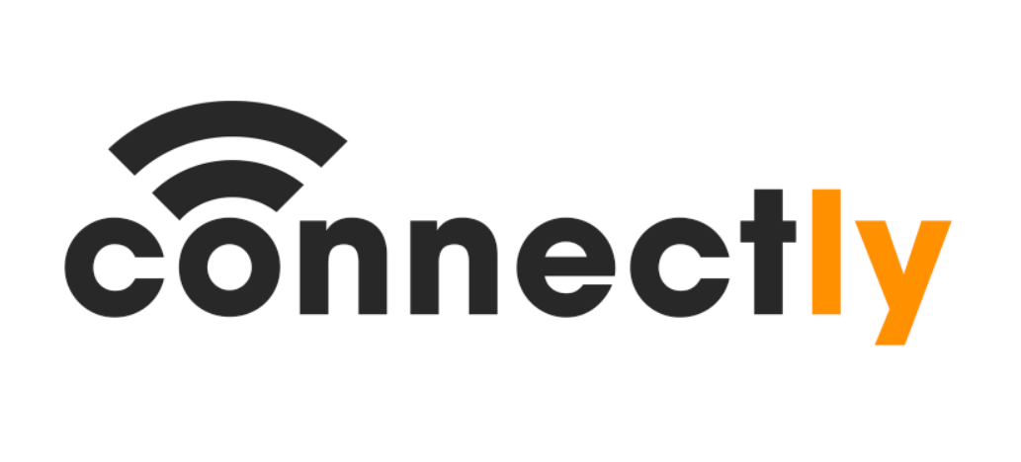

In the end we decided not to use this logo, but it did give us some inspiration for our final logo.

### Sketch 5 (Final logo)

#### Version 1

Our fifth and final sketch started of with a C around a dot in the middle. We surrounded this C with a circle. This way we would have a C incorporated into a compact logo, which is the idea we went for here.

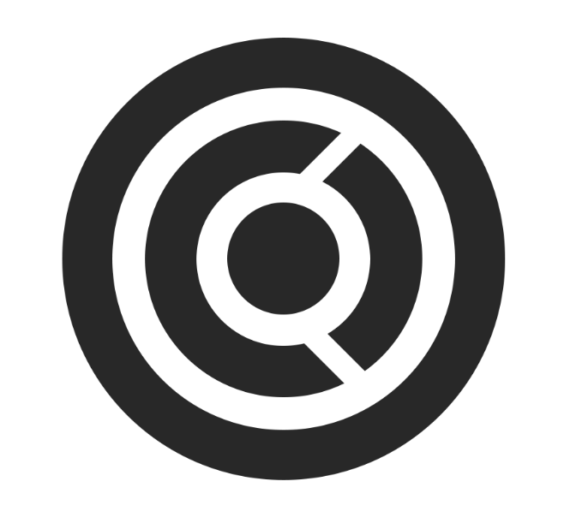

This logo did not feel complete however, so we decided to experiment a bit more with it. which is why we decided to color in the C. This logo felt complete as soon as we extended the white opening to the outer ring, to make it look like a signal came out of the C, which of course fits perfectly with the name ‘Connectly’.

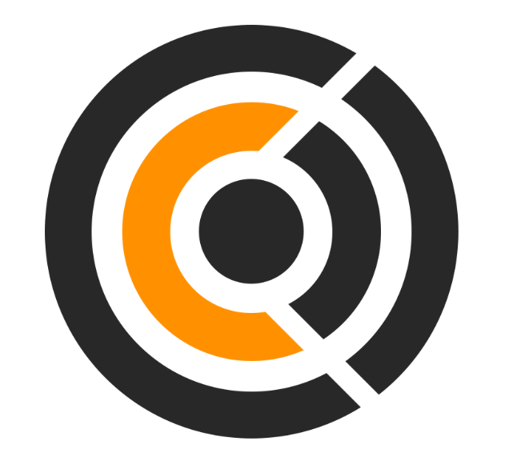

##### Symbolism

The thought behind this logo is as follows:

The circle in the center represents the user. Around the circle in the middle is a yellow ring. This ring represents people from different cultures (and thus is represented by a different color). The user doesn’t know these people yet, because he only ever interacts with the people within his radar (the two half rings to the right). With the use of this app however, he can get to know these bright people, and can thus expand his circle of friends, which is represented by the outer ring.

#### 

##### Combination

To finish the logo, we decided to combine this logo with the one we made at the second sketch. We put the compact logo above the font-logo, so that we have both and can use them together and apart from each other.

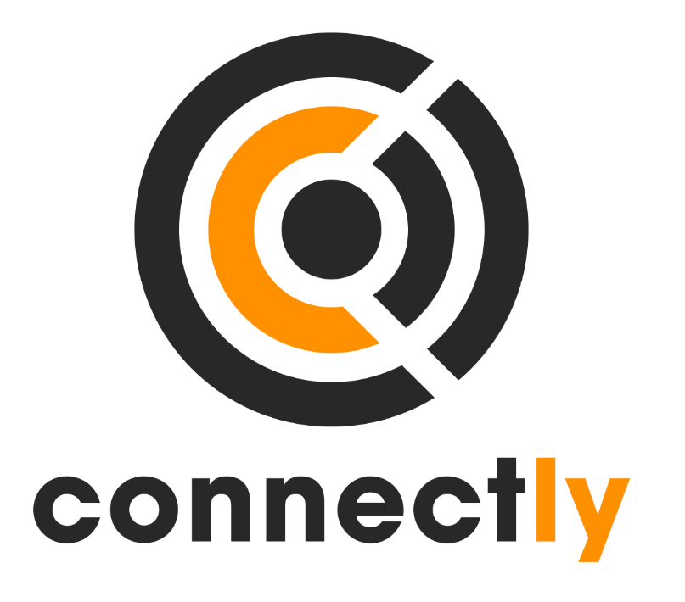

#### Version 2

##### Radar Concept

We decided to build on the previous concept a little more. For this version we tried incorporating the previous logo into a radar, since a radar is also a good way to show the user the people in your neighborhood that they can connect with. This way we could also make the C almost all the way around, to make it look a bit more like the C in the font-logo:

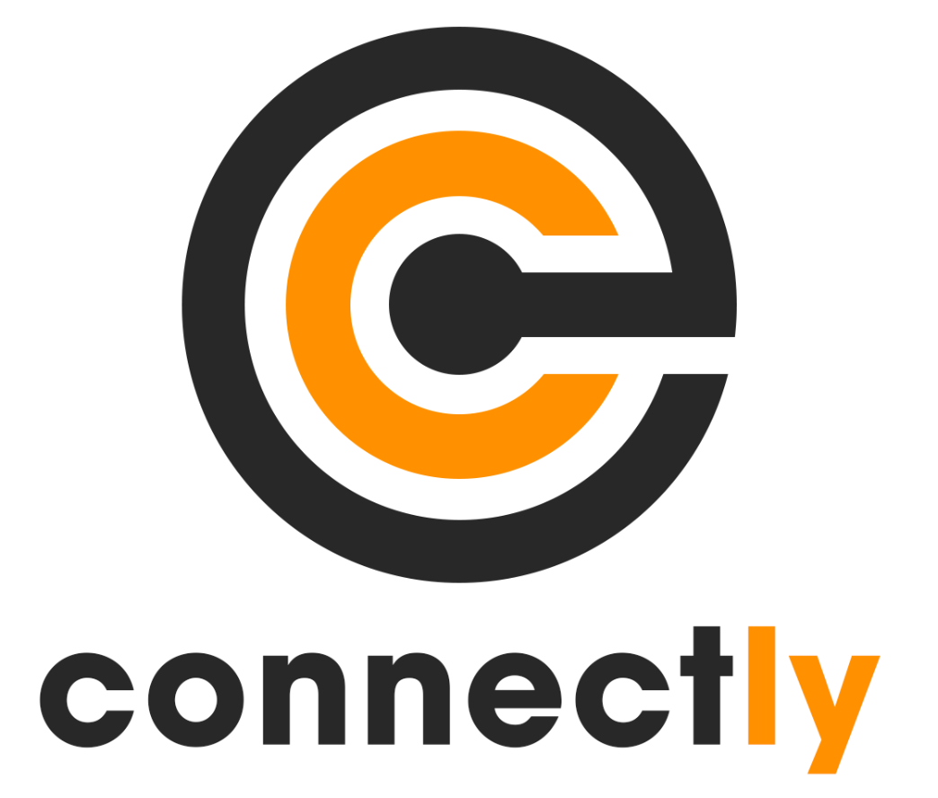

After some feedback we eventually decided to go with the first version, since most people we asked (including Olha) liked that one the most.